Assignment 6
PNR: 260740150018
Name: PRATIK SUNIL ABHANG

Question:
Write a Python menu-driven program to perform the following operations on a list of numbers:
1. Insert an element
2. Delete an element
3. Search for an element
4. Display the largest and smallest element
5. Display the list in reverse order
6. Exit

Program
def menu():
numbers = []
while True:
print("\n1. Insert")
print("2. Delete")
print("3. Search")
print("4. Largest and Smallest")
print("5. Reverse")
print("6. Exit")
choice = input("Enter choice: ")
if choice == "1":
numbers.append(int(input("Enter number: ")))
elif choice == "2":
number = int(input("Enter number: "))
if number in numbers:
numbers.remove(number)
else:
print("Number not found")
elif choice == "3":
number = int(input("Enter number: "))
print("Found:", number in numbers)
elif choice == "4" and numbers:
print("Largest:", max(numbers))
print("Smallest:", min(numbers))
elif choice == "5":
print("Reverse:", numbers[::-1])
elif choice == "6":
break
menu()

Input and Output
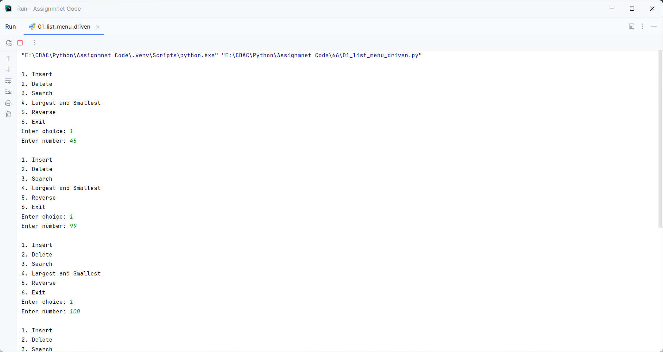
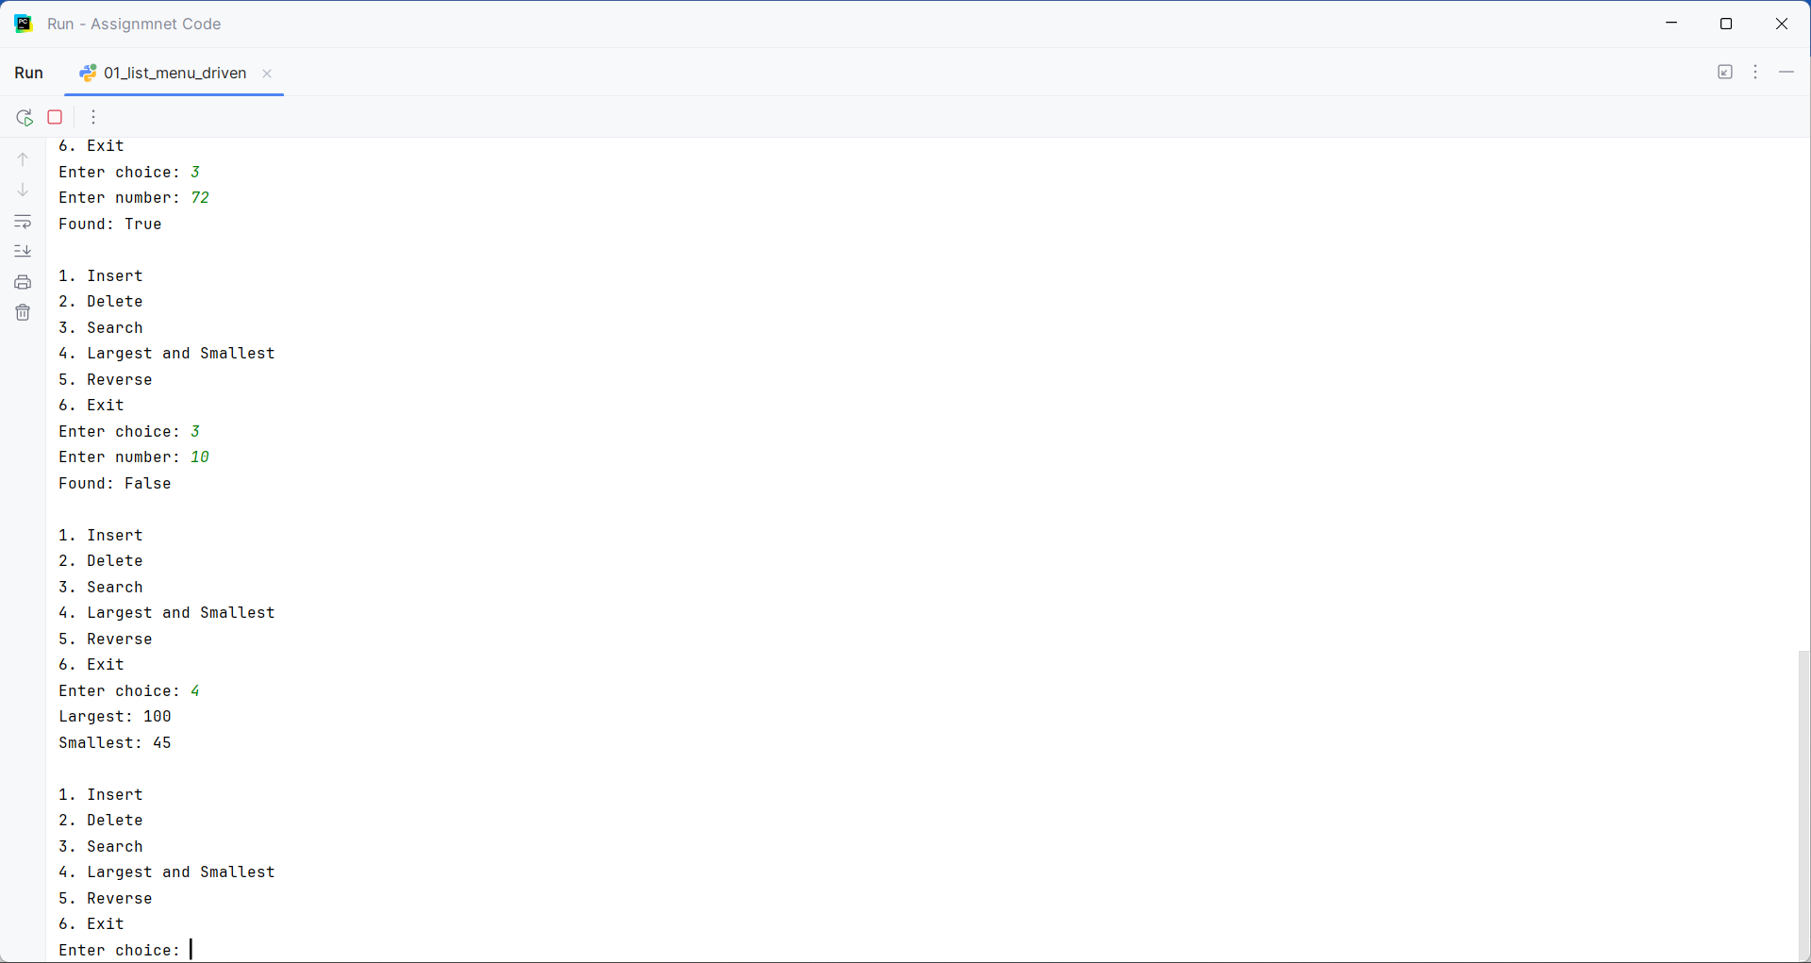
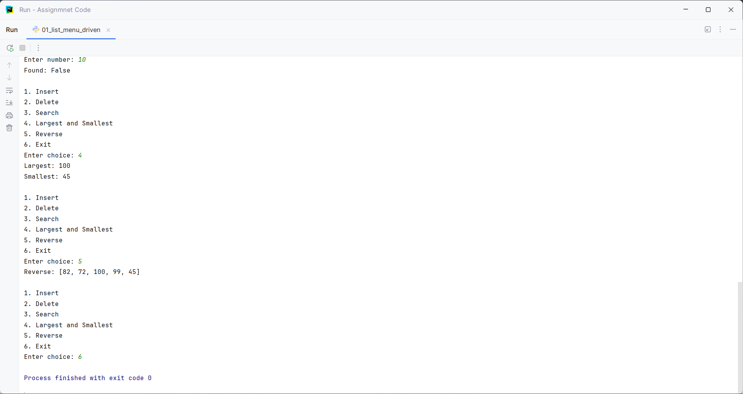

Question:
Write a Python program that accepts the names and marks of 5 students and writes the details to a file named students.txt. Then read the file and display only the students who scored more than 60 marks.

Program
def student_file():
n = int(input("Enter number of students: "))
with open("students.txt", "w") as file:
for i in range(n):
name = input("Enter student name: ")
marks = int(input("Enter marks: "))
file.write(name + "," + str(marks) + "\n")
with open("students.txt", "r") as file:
print("\nStudents scoring more than 60:")
for line in file:
name, marks = line.strip().split(",")
if int(marks) > 60:
print(name, marks)
student_file()

Input and Output
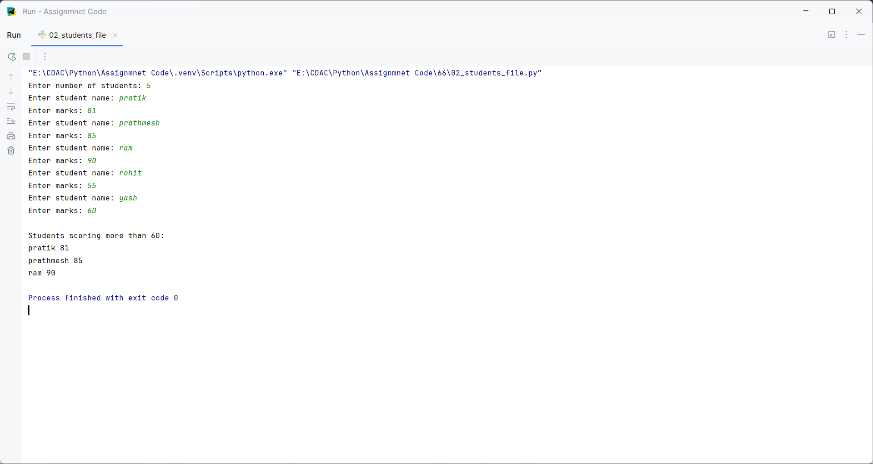

Question:
Write a Python program to read a text file and count:
• Number of lines
• Number of words
• Number of characters
• Number of vowels
Display the results separately.

Program
def count_file():
file_path_name = input("Enter file name or file path: ")
with open(file_path_name, "r") as file:
data = file.read()
vowels = 0
for char in data.lower():
if char in "aeiou":
vowels += 1
print("Number of lines:", len(data.splitlines()))
print("Number of words:", len(data.split()))
print("Number of characters:", len(data))
print("Number of vowels:", vowels)
count_file()

Input and Output
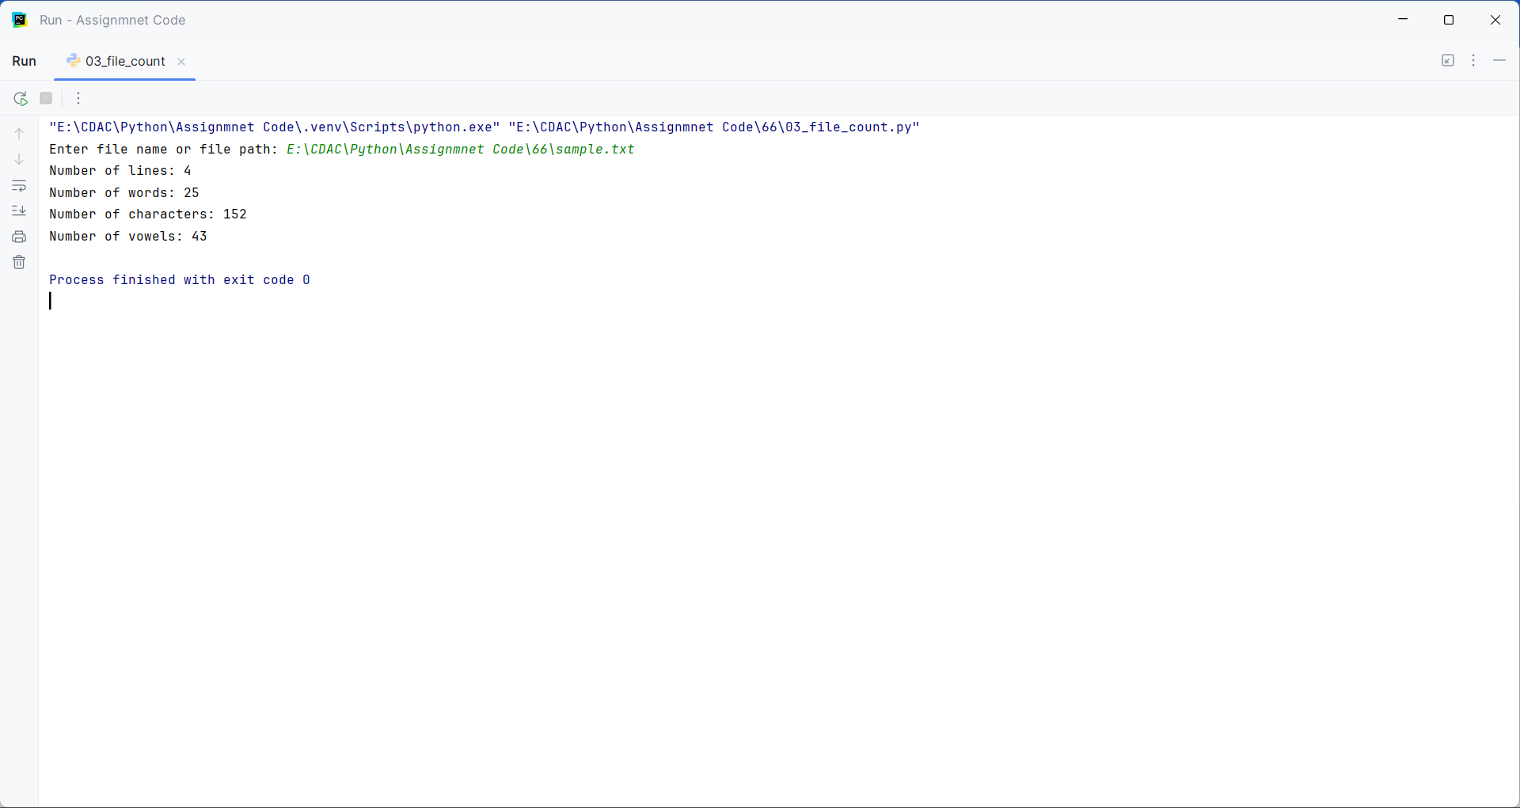

Question:
Using Python's os module, write a program to:
• Display the current working directory using getcwd().
• Create a directory named Practice using mkdir().
• Change to the Practice directory using chdir().
• Display all files and directories using listdir().

Program
import os
print("Current directory:", os.getcwd())
if not os.path.exists("Practice"):
os.mkdir("Practice")
os.chdir("Practice")
print("New directory:", os.getcwd())
print("Files and directories:", os.listdir())

Input and Output
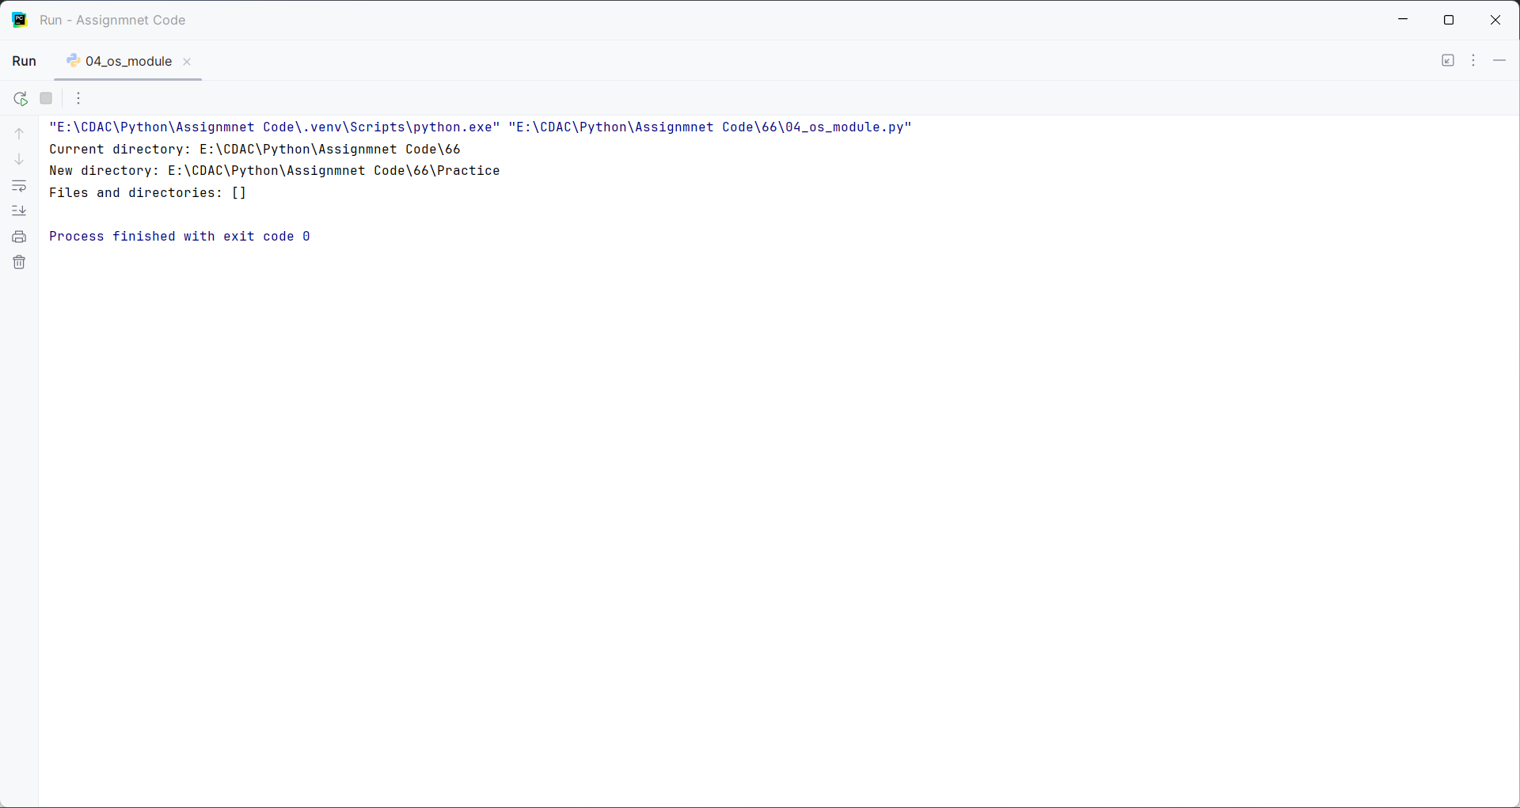

Question:
Write a Python program to accept 10 integers into a list and:
• Display all even numbers.
• Display all odd numbers.
• Find the sum and average.
• Find the largest and smallest number.
• Remove duplicate elements.

Program
def list_operations():
numbers = []
n = int(input("How many numbers do you want to enter? "))
for i in range(n):
number = int(input("Enter number: "))
numbers.append(number)
even = []
odd = []
for number in numbers:
if number % 2 == 0:
even.append(number)
else:
odd.append(number)
print("Even numbers:", even)
print("Odd numbers:", odd)
print("Sum:", sum(numbers))
print("Average:", sum(numbers) / len(numbers))
print("Largest:", max(numbers))
print("Smallest:", min(numbers))
print("Without duplicates:", list(set(numbers)))
list_operations()

Input and Output
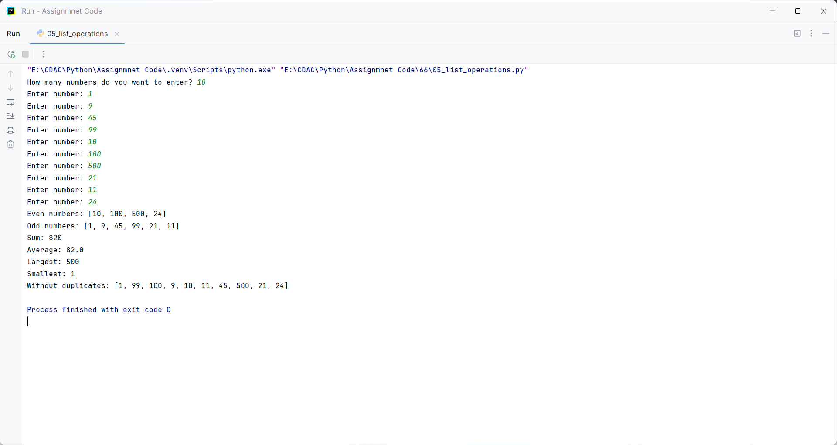

Question:
Write a Python program to create a tuple containing the marks of 10 students. Using appropriate tuple operations and functions:
• Display the highest mark.
• Display the lowest mark.
• Calculate the average.
• Count how many students scored above 75.
• Search for a particular mark.

Program
def tuple_operations(marks):
print("Highest:", max(marks))
print("Lowest:", min(marks))
print("Average:", sum(marks) / len(marks))
count = 0
for mark in marks:
if mark > 75:
count += 1
print("Above 75:", count)
search = int(input("Enter mark to search: "))
print("Found:", search in marks)
marks = []
for i in range(10):
marks.append(int(input("Enter mark: ")))
tuple_operations(tuple(marks))

Input and Output
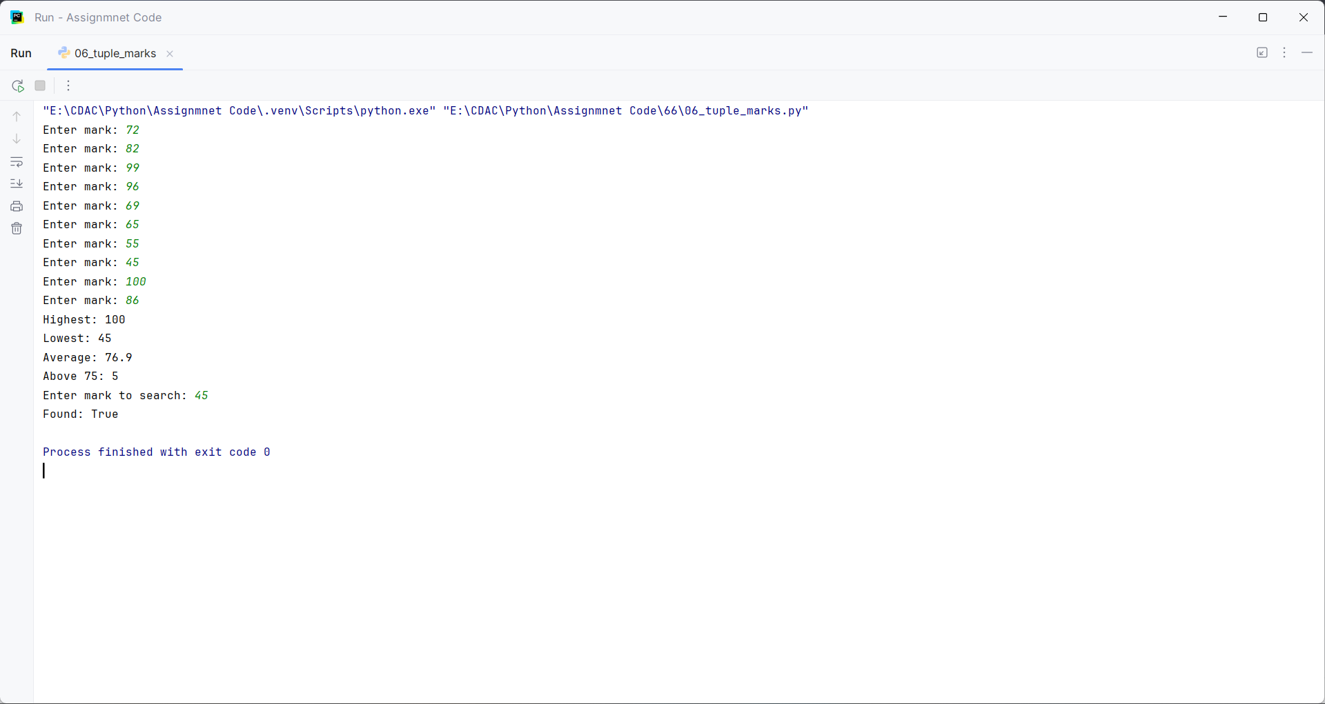

Question:
Create two sets representing students enrolled in Python and Java courses.
Write a program to display:
• Students enrolled in both courses.
• Students enrolled only in Python.
• Students enrolled only in Java.
• Students enrolled in either course.
• Students enrolled in neither course, given a separate set containing all students.

Program
python_students = set(input("Enter Python students names separated by space: ").split())
java_students = set(input("Enter Java students names separated by space: ").split())
all_students = set(input("Enter all students names separated by space: ").split())
print("Both courses:", python_students & java_students)
print("Only Python:", python_students - java_students)
print("Only Java:", java_students - python_students)
print("Either course:", python_students | java_students)
print("Neither course:", all_students - (python_students | java_students))

Input and Output
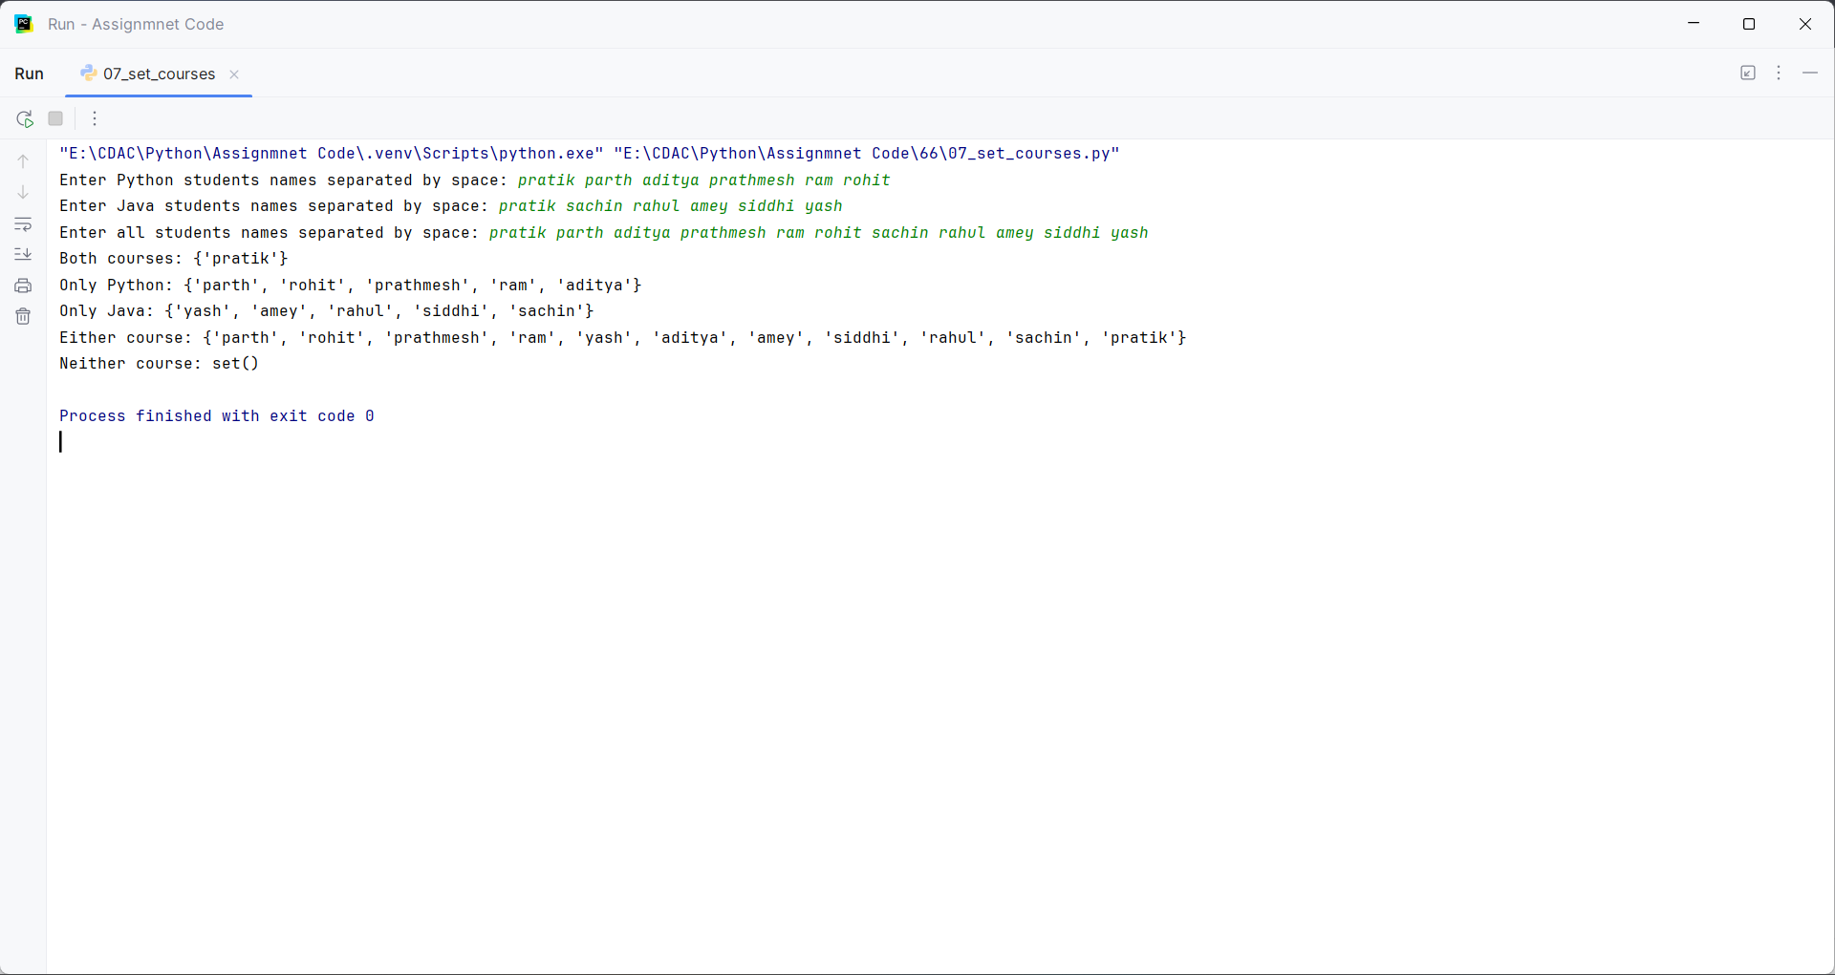

Question:
Write a Python program to accept a sentence from the user and:
• Count vowels.
• Count digits and spaces.
• Display the number of words.
• Display the sentence in reverse.
• Check whether the sentence is a palindrome after ignoring spaces and case.

Program
sentence = input("Enter a sentence: ")
vowels = 0
digits = 0
spaces = 0
for char in sentence.lower():
if char in "aeiou":
vowels += 1
if char.isdigit():
digits += 1
if char == " ":
spaces += 1
print("Vowels:", vowels)
print("Digits:", digits)
print("Spaces:", spaces)
print("Words:", len(sentence.split()))
print("Reverse:", sentence[::-1])
text = sentence.replace(" ", "").lower()
print("Palindrome:", text == text[::-1])

Input and Output
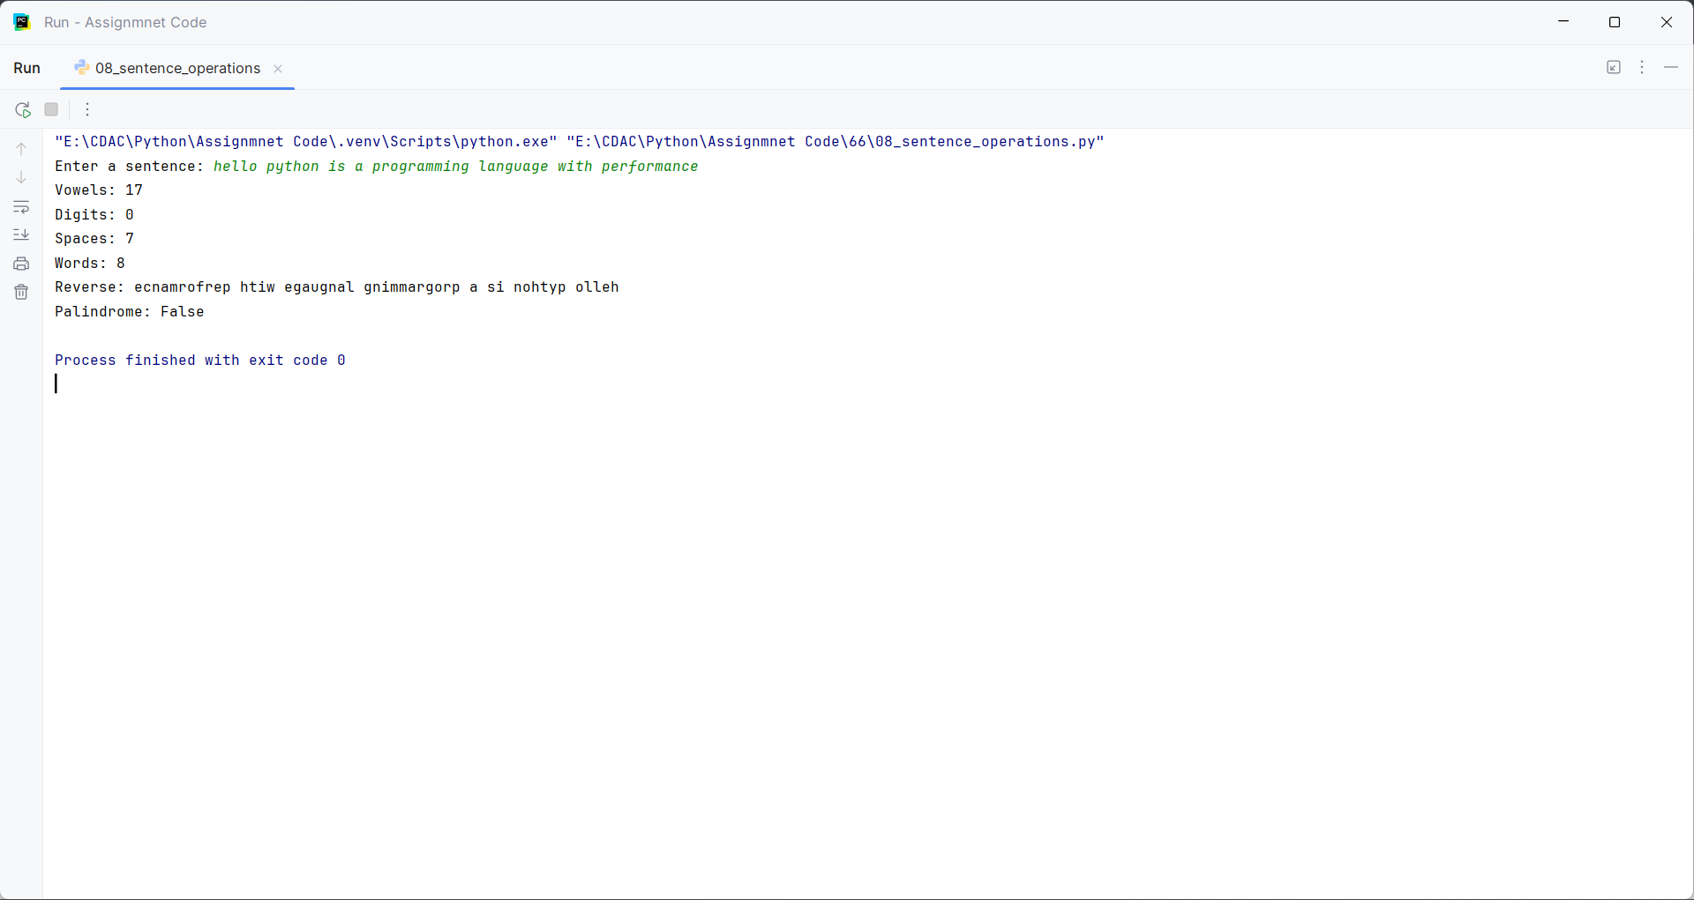

Question:
Create a dictionary containing student names and their marks.
Write a program to:
• Add a new student.
• Update an existing student's marks.
• Delete a student.
• Search for a student.
• Display students who scored above 75.
• Display the student with the highest marks.

Program
students = {"Pratik": 80, "Prathmesh": 70}
while True:
print("\n1. Add")
print("2. Update")
print("3. Delete")
print("4. Search")
print("5. Above 75")
print("6. Highest")
print("7. Exit")
choice = input("Enter choice: ")
if choice == "1":
name = input("Enter student name: ")
marks = int(input("Enter marks: "))
students[name] = marks
elif choice == "2":
name = input("Enter student name: ")
if name in students:
students[name] = int(input("Enter new marks: "))
else:
print("Student not found")
elif choice == "3":
name = input("Enter student name: ")
if name in students:
del students[name]
else:
print("Student not found")
elif choice == "4":
name = input("Enter student name: ")
print("Found:", name in students)
elif choice == "5":
print("Students above 75:")
for name, marks in students.items():
if marks > 75:
print(name, marks)
elif choice == "6":
if students:
name = max(students, key=students.get)
print("Highest:", name, students[name])
elif choice == "7":
print("Exit")
break
else:
print("Invalid choice")

Input and Output

